**Project Name:** Learning Management System

**Project Members:**

|  |  |
| --- | --- |
| **PRN No.** | **Name** |
| 220943120008 | Akash Pandit Kate |
| 220943120042 | Jungade Pranav Prashant |
| 220943120056 | Kulkarni Prasad Pradip |
| 220943120114 | Yogesh Kalyan Jathar |

**Introduction of Project:**

The main objective of the project is to create a learning management system by which the students, teachers and back-office staff can track the courseware, examination and attendance process digitally with ease. Currently, all these processes are on paper which is tedious, clumsy and not techno-friendly. For implementation of the project, the institute needs a basic server to run the application and a router to connect to the personal devices of the students.

The system is implemented by 3-tier approach with a backend database, a middle tier Spring Boot, and web browser as front-end client. In order to develop this application, several technologies like MySQL for relational database, programming languages like core Java and web-based Java for implementing Spring boot technology and scripting libraries based on JavaScript like React.js.

**Objective and Scope of Project:**

The objective of this project is to develop an environment where the learning and learning related-administrative activities can be digitized. The project can maintain records of student’s educational activities by the coordinator and other non-teaching staff while the teaching staff can provide educational material to the student. The student can receive timely updates of schedule, test, notices and result, while facilitated to give attendance.

**Modification and improvement over the existing Implementation:**

Presently, the student can get schedule, test, notices and result. The back-office user can create tests, schedules and notices. The teacher can provide study links to the students.

**Project Plan:**

No. of User’s and Modules:-

* **Users-** Students, Teachers and Back-office staff.
* **Modules** -

We can logically separate the entire project in three major modules. The modules for Learning Management System are:-

1. Course management : The courses and its study material is provided and managed by teacher and student can view it.

2. Profile Management: Each user can view their profile but the profile can be edited only by back-office staff.

3. Exam-Result Management: The back-office staff can generate tests and give marks to the student based on the test. The student can access the test as per test id and appear for the test.

**Technology:**

* **Frontend - React.js**

A JavaScript library for building user interface. React development is led by a small dedicated team working full time at Meta. It also receives contributions from people all over the world.

* **Backend - Java Spring Boot (J2EE)**

It is an open-source Java-based framework used to create a microservice. Microservice is an architecture that allows the developers to develop and deploy services independently. Each service running has its own process and this achieves the lightweight model to support business applications.

**Features of Spring Boot:**

* Create stand-alone Spring applications
* Embed Tomcat, Jetty or Undertow directly (no need to deploy WAR files)
* Provide opinionated 'starter' dependencies to simplify your build configuration
* Automatically configure Spring and 3rd party libraries whenever possible
* Provide production-ready features such as metrics, health checks, and externalized configuration
* Absolutely no code generation and no requirement for XML configuration
* **Database - MySQL**

MySQL, the most popular open-source SQL database management system, is developed, distributed, and supported by Oracle Corporation.

**Features of MySQL:**

* **MySQL is a database management system.**

A database is a structured collection of data. It may be anything from a simple shopping list to a picture gallery or the vast amounts of information in a corporate network. To add, access, and process data stored in a computer database, you need a database management system such as MySQL Server. Since computers are very good at handling large amounts of data, database management systems play a central role in computing, as standalone utilities, or as parts of other applications.

* **MySQL databases are relational.**

A relational database stores data in separate tables rather than putting all the data in one big storeroom. The database structures are organized into physical files optimized for speed. The logical model, with objects such as databases, tables, views, rows, and columns, offers a flexible programming environment.

* **MySQL software is open-source.**

Open Source means that it is possible for anyone to use and modify the software. Anybody can download the MySQL software from the Internet and use it without paying anything.

* **The MySQL Database Server is very fast, reliable, scalable, and easy to use.**

MySQL Server was originally developed to handle large databases much faster than existing solutions and has been successfully used in highly demanding production environments for several years. Although under constant development, MySQL Server today offers a rich and useful set of functions. Its connectivity, speed, and security make MySQL Server highly suited for accessing databases on the Internet.

* **MySQL Server works in client/server or embedded systems.**

The MySQL Database Software is a client/server system that consists of a multithreaded SQL server that supports different back ends, several different client programs and libraries, administrative tools, and a wide range of application programming interfaces (APIs).

**Roles and Responsibilities:**

|  |  |  |
| --- | --- | --- |
| **Roles And Responsibilities** | | |
| 1 | Role | Frontend Developer |
| Member Name | Jungade Pranav Prashant |
| PRN No | 220943120042 |
| Description | Worked on React.js using IDE Visual Studio Code |
| 2 | Role | Backend Developer |
| Member Name | Akash Pandit Kate |
| PRN No | 220943120008 |
| Description | Worked on Java Spring Boot using Ecllipse IDE |
| 3 | Role | Database Developer |
| Member Name | Kulkarni Prasad Pradip |
| PRN No | 220943120056 |
| Description | Worked on Java Spring Boot using Ecllipse IDE |
| 4 | Role | Backend Developer |
| Member Name | Yogesh Kalyan Jathar |
| PRN No | 220943120114 |
| Description | Worked on relation database using MySQL |

**Data Flow Diagram (DFD):**

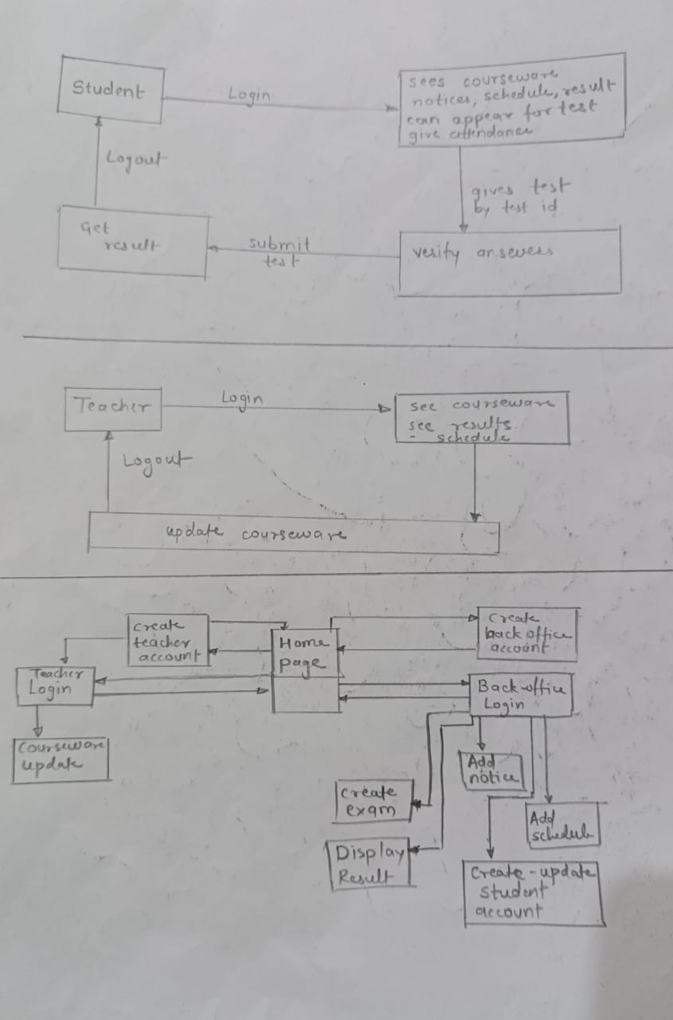

**ERD / Database Tables:**

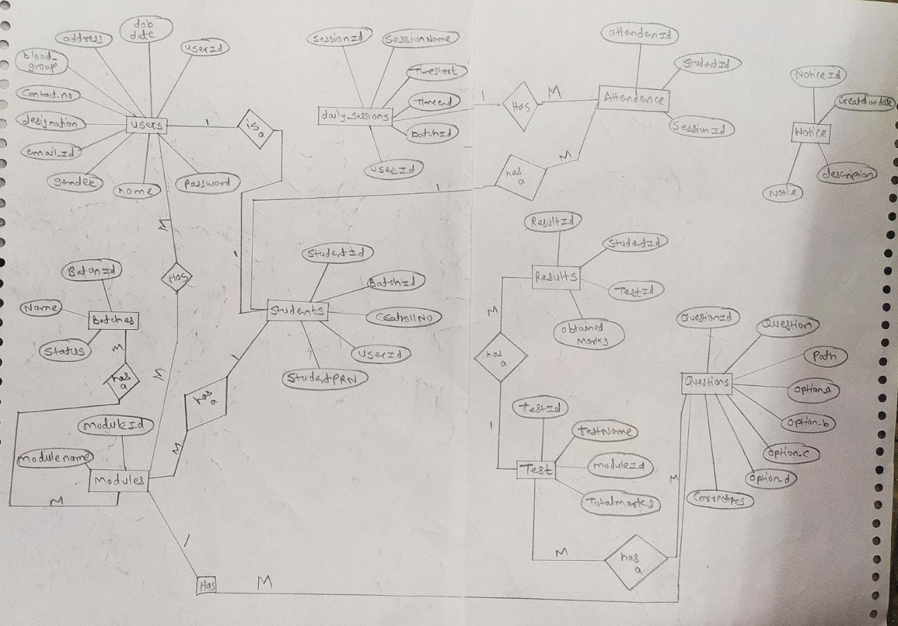

1. batches

|  |  |  |  |  |  |
| --- | --- | --- | --- | --- | --- |
| **Field** | **Type** | **Null** | **Key** | **Default** | **Extra** |
| batch_id | int | NO | PRI | NULL | auto_increment |
| name | varchar(255) | YES |  | NULL |  |
| status | varchar(255) | YES |  | NULL |  |

1. daily_attendence

|  |  |  |  |  |  |
| --- | --- | --- | --- | --- | --- |
| **Field** | **Type** | **Null** | **Key** | **Default** | **Extra** |
| attendence_id | int | NO | PRI | NULL | auto_increment |
| daily_session_session_id | int | YES | MUL | NULL |  |
| student_student_id | int | YES | MUL | NULL |  |

1. daily_session

|  |  |  |  |  |  |
| --- | --- | --- | --- | --- | --- |
| **Field** | **Type** | **Null** | **Key** | **Default** | **Extra** |
| session_id | int | NO | PRI | NULL | auto_increment |
| Field | Type | Null | Key | Default |  |
| date | date | YES |  | NULL |  |
| session_name | varchar(255) | YES |  | NULL |  |
| time_start | time | YES |  | NULL |  |
| timeend | time | YES |  | NULL |  |
| batch_batch_id | int | YES | MUL | NULL |  |
| user_user_id | int | YES | MUL | NULL |  |

1. modules

|  |  |  |  |  |  |
| --- | --- | --- | --- | --- | --- |
| **Field** | **Type** | **Null** | **Key** | **Default** | **Extra** |
| module_id | int | NO | PRI | NULL | auto_increment |
| module_name | varchar(255) | YES |  | NULL |  |

1. modules_user_list

|  |  |  |  |  |  |
| --- | --- | --- | --- | --- | --- |
| **Field** | **Type** | **Null** | **Key** | **Default** | **Extra** |
| module_list_module_id | int | NO | MUL | NULL |  |
| user_list_user_id | int | NO | MUL | NULL |  |

1. notice

|  |  |  |  |  |  |
| --- | --- | --- | --- | --- | --- |
| **Field** | **Type** | **Null** | **Key** | **Default** | **Extra** |
| id | int | NO | PRI | NULL | auto_increment |
| created_on | date | YES |  | NULL |  |
| description | varchar(255) | YES |  | NULL |  |
| notice | varchar(255) | YES |  | NULL |  |

1. pdfs

|  |  |  |  |  |  |
| --- | --- | --- | --- | --- | --- |
| **Field** | **Type** | **Null** | **Key** | **Default** | **Extra** |
| pdf_id | int | NO | PRI | NULL | auto_increment |
| name | varchar(255) | YES |  | NULL |  |
| path | varchar(255) | YES |  | NULL |  |
| module_module_id | int | YES | MUL | NULL |  |

1. questions

|  |  |  |  |  |  |
| --- | --- | --- | --- | --- | --- |
| **Field** | **Type** | **Null** | **Key** | **Default** | **Extra** |
| question_id | int | NO | PRI | NULL | auto_increment |
| question_id | varchar(255) | YES |  | NULL |  |
| option_a | varchar(255) | YES |  | NULL |  |
| option_b | varchar(255) | YES |  | NULL |  |
| option_c | varchar(255) | YES |  | NULL |  |
| option_d | varchar(255) | YES |  | NULL |  |
| path | varchar(255) | YES |  | NULL |  |
| question | varchar(255) | YES |  | NULL |  |
| weightage | int | NO |  | NULL |  |
| module_module_id | int | YES | MUL | NULL |  |

1. results

|  |  |  |  |  |  |
| --- | --- | --- | --- | --- | --- |
| **Field** | **Type** | **Null** | **Key** | **Default** | **Extra** |
| result_id | int | NO | PRI | NULL | auto_increment |
| obtained_marks | int | NO |  | NULL |  |
| student_student_id | int | YES | MUL | NULL |  |
| test_test_id | int | YES | MUL | NULL |  |

1. students

|  |  |  |  |  |  |
| --- | --- | --- | --- | --- | --- |
| **Field** | **Type** | **Null** | **Key** | **Default** | **Extra** |
| student_id | int | NO | PRI | NULL | auto_increment |
| ccat_roll_no | bigint | NO |  | NULL |  |
| studentprn | bigint | NO |  | NULL |  |
| batch_batch_id | int | YES | MUL | NULL |  |
| user_user_id | int | YES | MUL | NULL |  |

1. tests

|  |  |  |  |  |  |
| --- | --- | --- | --- | --- | --- |
| **Field** | **Type** | **Null** | **Key** | **Default** | **Extra** |
| test_id | int | NO | PRI | NULL | auto_increment |
| test_name | varchar(255) | YES |  | NULL |  |
| total_marks | int | NO |  | NULL |  |
| module_module_id | int | YES | MUL | NULL |  |

1. tests_question_list

|  |  |  |  |  |  |
| --- | --- | --- | --- | --- | --- |
| **Field** | **Type** | **Null** | **Key** | **Default** | **Extra** |
| test_list_test_id | int | NO | MUL | NULL |  |
| question_list_question_id | int | NO | MUL | NULL |  |

1. users

|  |  |  |  |  |  |
| --- | --- | --- | --- | --- | --- |
| **Field** | **Type** | **Null** | **Key** | **Default** | **Extra** |
| user_id | int | NO | PRI | NULL | auto_increment |
| dob | date | YES |  | NULL |  |
| address | varchar(255) | YES |  | NULL |  |
| blood_group | varchar(255) | YES |  | NULL |  |
| contact_no | varchar(255) | YES |  | NULL |  |
| designation | int | YES |  | NULL |  |
| email_id | varchar(255) | YES |  | NULL |  |
| gender | varchar(255) | YES |  | NULL |  |
| name | varchar(255) | YES |  | NULL |  |
| password | varchar(255) | YES |  | NULL |  |

**Future Scope:**

The application can be developed further developed for in-app compiler for conducting practical exam.